Acid Rain Worksheet

pH scale
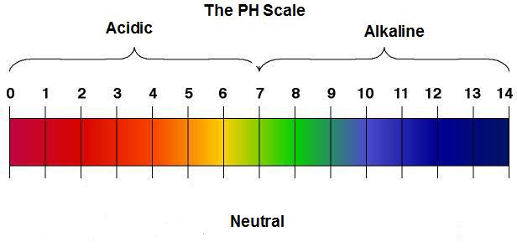
- What is the pH of natural rainwater? _______________

- Why is rainwater natural acidic?

- Show the synthesis equation for the reaction of carbon dioxide with water.

_________________ + _________________ _________________________

- What is the lowest pH of ‘acid rain’? ___________

- How much more acidic is a pH of 3 compared to a pH of 6? _________________

- How much more acidic is a pH of 4 compared to a pH of 6? _________________

SULPHUR COMPOUNDS

- What type of compounds do plants take in to help them grow? ___________________

- Give an example of this type of sulphur compound found natural in the soil that is taken up by the plants. ___________________.

- When the plant dies, the sulphur remains bonded to the carbon to form coal and oil also known as fossil fuels. The sulphur content percentage is __________% by weight.

- Show balanced chemical equations that depict how the burning of sulphur creates sulphuric acid in rain.

- Burning of sulphur with oxygen molecule in air

- In the presence of sunlight, sulphur dioxide reacting with more oxygen molecule

- Synthesis reaction of sulphur trioxide in the presence of rain water

NITROGEN COMPOUNDS

- Show balanced chemical equations that depict how the burning of nitrogen creates nitric acid in rain.

- What compound do vehicles produce that contribute to acid rain formation?

- Show the synthesis reaction of nitrogen from the air reacting with oxygen in an engine?

- Show the reaction of NO with more oxygen in the air to create nitrogen trioxide. Don’t worry about balancing this one.

- Synthesis reaction of nitrogen trioxide in the presence of rain water

Highlight the effects of acid rain on air, water, soil, vegetation, animals, and human health. Come up with at least one main impact for each of the areas. Research.

