Please answer the following questions while watching the video about the evolution of the eye. This will be counted as part of your course mark.

- Sharpest eyes belong to ___________________ of __________________.

- The larger the animals eye the _________________________ its vision.

- Eagle can magnify its helpless prey __________ x compared to the human eye.

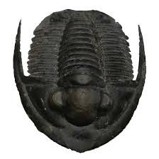
- What happens when a jelly fish is subjected to green light waves? _________________

- What happens when a jelly fish is subjected to purple light waves? _________________
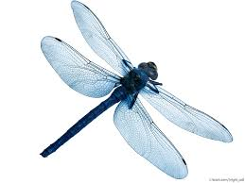
- Trilobites from the Cambrian times are the first sign of what type of eye? _________________ eyes. Their eyes are made of _______________. This calcite mineral is secreted from their skin.

- The most abundant (numerous) lifeform on land is the _________________. A bee has __________ lenses per eye. The ____________fly has 29 000 lenses making for the ultimate motion detector.

- The vertebrate eye are those with a backbone this includes reptiles, mammals and ____________.
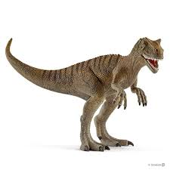
- Carnivorous dinosaurs are great predators due to __________________ vision that is two eyes are more forward. This advantage is very good for making fine depth judgement and 3D vision.

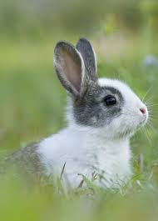
- Allosaurus does not have binocular vision. They have lateral facing eyes which make them an _________________ predator whereby they wait and take out their prey.

- Rabbit eyes sit high and to the sides. This allows it to see ___________ degrees.

- Nocturnal animals can see during the ________________. When comparing eye balls of a night time animal with a day time animal, the main difference is the size of the ___________________. The cornea is a clear curved shell that provides focusing power.

- Cats like lions are good night hunters because of their eye shine. The cat’s eye when dissected reveals a layer behind the retina called the tapetum lucidum which is latin for “bright _____________”. Cats only need _________ of the light that humans need to be active in the dark.

- Why was it important for primates like the monkeys to have eyes that evolved to see the colour red?

