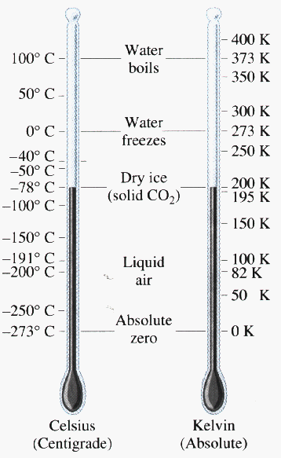**Temperature**

Definition:

STP conditions:

Absolute Zero:

**Celcius-Kelvin Temperature Conversions**

1. Liquid nitrogen (sometimes abbreviated LOX) is used in liquid-fuel rockets. Its boiling  point is -183oC. What is this temperature in kelvins?
2. A substance is heated from 300 K to 315 K. What is the change in temperature expressed in oC?
3. Perform the following conversions.

a)  24oC to K                                         b)  50 K  to oC

c)  30oC to K                                         d)  215.15 K  to oC

e)  -37.89oC to K                                   f)   333.67 K to oC

1. A clinical thermometer registers a patient's temperature to be 37.13oC. What is this in kelvins?
2. The coldest permanenty inhabited place on earth is the Siberian village of Oymyakon in Russia. In 1964 the temperature reached a shivering -71.11oC. What is this temperature in kelvins?
3. Helium has the lowest boiling point of any liquid. It boils at 4 K. What is this in oC?

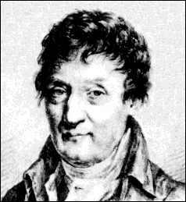**Go to our class website and click on the link Charles Law Simulation**

**Charles Law Lab**

**Or enter: http://bit.ly/2rpD4iZ**

[**http://dbpoc.com/pearson/chemsims/gold/kmtgold/KMT.php**](http://dbpoc.com/pearson/chemsims/gold/kmtgold/KMT.php)

**Purpose:** What is the relationship between temperature and volume of a gas?

**Procedure:**

1. Select **Experiment** from tab above and then select **Run Experiment**.
2. a) Set the controls for the experiment so that the Responding Variable (Rspd button) is beside volume. The pressure is a control variable and should be set at 0.50 atm.

b) Move the slider for temperature all the way to the left, starting at 50.00K.

c) Helium should be selected as the gas starting with 0.05 mols.

1. 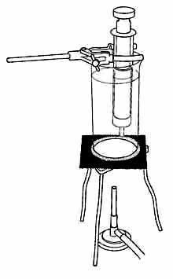Push the record button in the top right corner.

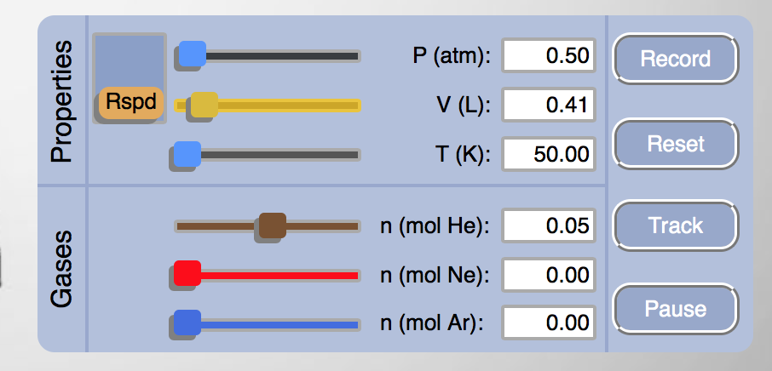

1. Move the temperature gauge to 100 Kelvin. Push record button. Continue to move the temperature gauge increasing by 50K each time until you reach 400K. Push Record after every 50 K increment.
2. Make note of what is happening to the left in the Gas Sample Container.
3. 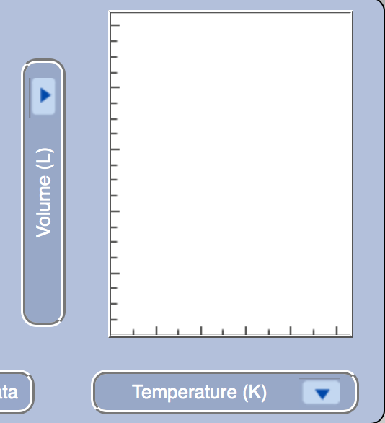Change the y axis on the graphs so that it is reading Volume. The x axis is already Temperature (K). Click Graph Data. Make a sketch of your findings on the graph below.
4. Convert your Kelvin temperatures to Celsius Temperatures. (K🡪oC -273)
5. On Google Sheets plot a graph of Temperature (o Celsius) and volume. **Make sure your x axis is temperature and goes from negative -300 to positive 100**.
6. Draw a line of best fit [Trend line – linear] through your points making sure that the line intersects the x axis.

**Data Table:**

|  |  |  |
| --- | --- | --- |
| **Temperature in Kelvin** | **Temperature in Celsius** | **Volume (L)** |
| 50 |  |  |
| 100 |  |  |
| 150 |  |  |
| 200 |  |  |
| 250 |  |  |
| 300 |  |  |
| 350 |  |  |
| 400 |  |  |

**Questions:**

1. What temperature does **volume** of trapped air become zero on the Kelvin scale and on the Celsius scale?
2. What is the significance of this temperature? Define this term.
3. Is there a temperature at which trapped air actually occupies zero volume? Why?
4. What does your graph indicate about the relationship between volume and temperature?
5. Explain this relationship using the Kinetic Molecular Theory.