Intermolecular forces control how well molecules stick together. This affects many of the measurable physical properties of substances:

Melting and Boiling Points
- If molecules stick together more, they'll be tougher to break apart
- Stronger intermolecular forces → higher melting and boiling points
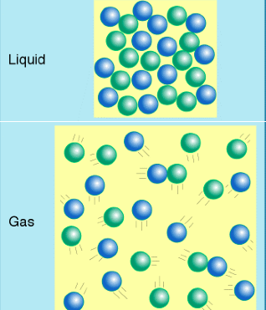
When a substance boils (goes from the liquid state to the gaseous state) the molecules go from being very close together as a liquid to being separated at a distance as a gas. If the molecules are attracted to each other, it will be much more difficult to separate them; thus the boiling point should go up.
To go from a liquid to a gas, the liquid particles have to be heated until they vibrate fast enough to break away from each other completely and zip around their container bumping into each other and the walls. If the particles are attracted to each other because of IMFs, this will require more energy and make the boiling point increase.

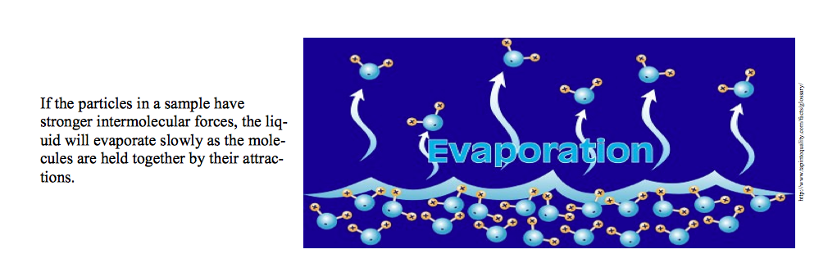
Evaporation

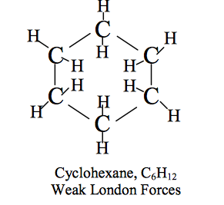
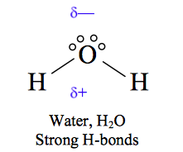
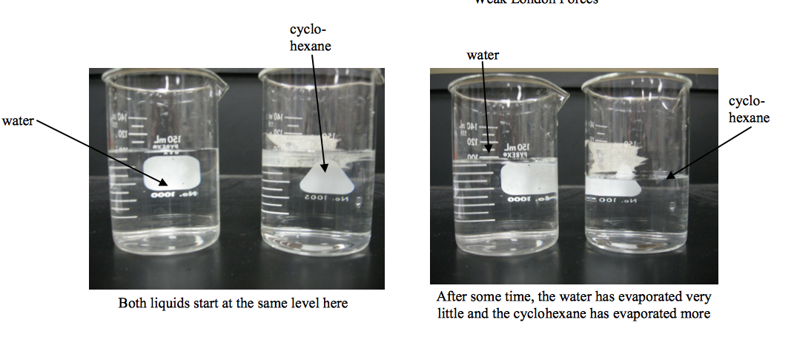
Look at the picture below. Two beakers were filled to the 100 mL mark; one with water and one with cyclohexane. Water is polar with strong H-bonds while cyclohexane is non-polar with only weak London Forces. The beakers were allowed to sit, side-by-side for a period of time. The water has hardly evaporated at all while a considerable amount of the cyclohexane has evaporated in the same time period. Cyclohexane is held together weaker than water and thus the molecules evaporate faster.

Viscosity
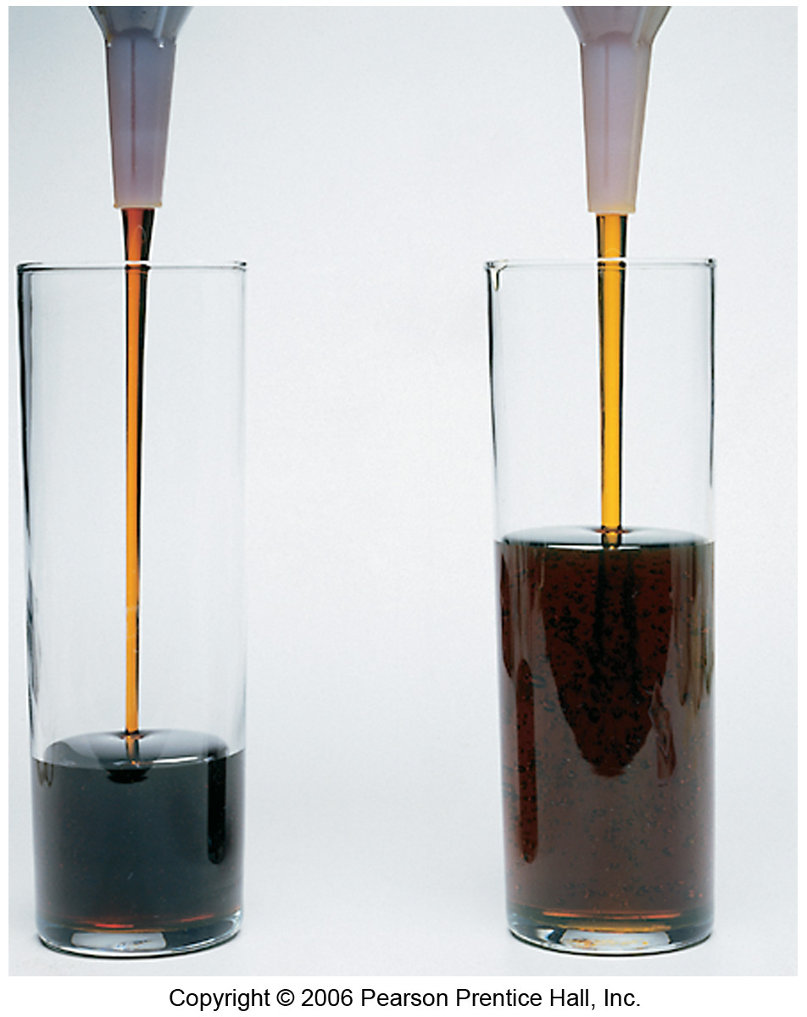
- Viscosity is a measure of how well substances flow.
- Low = Flow High = Thick
- Stronger intermolecular forces → higher viscosity.

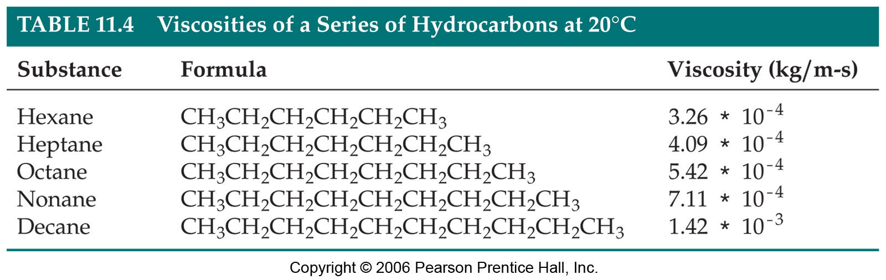

Decane is a larger molecule and has more electrons therefore stronger London Forces and is therefore more viscous.
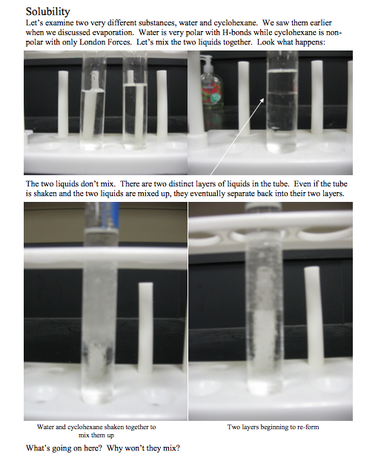
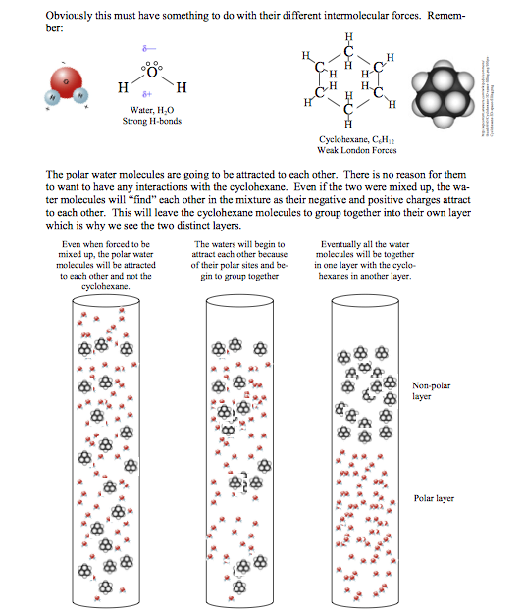
The basic idea from the previous example is that molecules that are polar do not tend to mix with those that are non-polar. Polar and non-polar don’t mix.

Recall:

- “Like dissolves like”
- Liquids with similar structures (similar type & magnitude of intermolecular forces) will be soluble in each other in all proportions
- Polar and Ionic solutes Dissolve in Polar Solvents and Non-polar solutes dissolve in non-polar solvents

- When a pentane molecule passes into a volume of hexane molecules, there is no significant environment change as both molecules are non-polar only exhibiting London Forces. They will be miscible.

There are many other factors that are affected by IMF’s such as surface tension and specific heat capacity. We will just focus on those mentioned above.

If you are asked to rank molecules in order of melting point, boiling point, viscosity or rate of evaporation, what I am actually asking is for you to rank them by strength of intermolecular forces (either increasing or decreasing).

Here is my strategy for this:
- Look for molecules with hydrogen bonding. They will have the strongest intermolecular forces
- Look for molecules with dipoles. These will have the next strongest intermolecular forces.
- Larger molecules will have stronger London dispersion forces. These are the weakest intermolecular forces but will often be the deciding factor.

Try These

- Put the following substances in order of increasing boiling points.

C₂H₆ CH₄ CH₃OH
- Which of the following substances will most likely evaporate the fastest?
C₂H₆ CH₄ CH₃OH

- If you wanted to dissolve grease, a non-polar substance, off your hands, which of the following liquids would be best?

Water, H₂O Antifreeze C₂H₄(OH)₂ Gasoline C₈H₁₈

