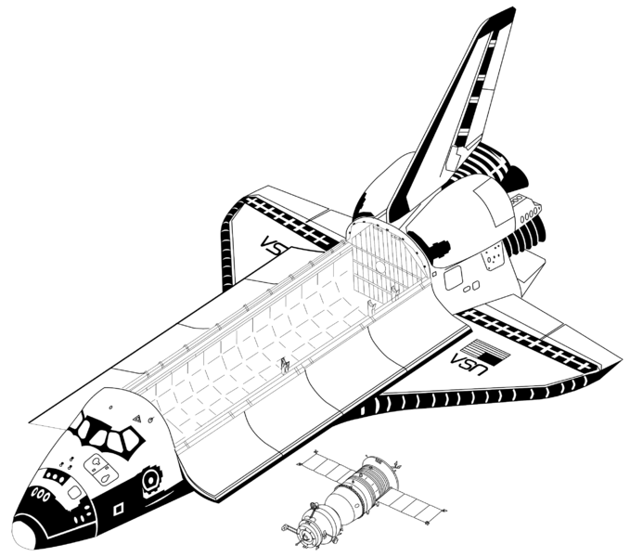
Objective: Determine stoichiometric relationships using an equation table. Show Full Solutions.

Exercise 1: Canisters containing LiOH are used to remove CO₂ from the air in enclosed spaces such as spacecraft. The balanced equation for this reaction is

2LiOH(s) + CO₂(g) → Li₂CO₃(s) + H₂O(l)

Assuming 1400 g of CO₂ is produced by the occupants of a spacecraft over a 24-hour period, how many grams of LiOH will be needed to consume all the CO₂ produced for a whole day?

Exercise 2: Propane, C₃H₈, is a typical flamethrower fuel. Military forces continue to use these sorts of weapons today, but the technology is more commonly used for nonviolent civilian purposes. Most notably, foresters use flamethrowers in prescribed burning and farmers use it to clear fields. Some car enthusiasts install low-range flame throwers at the back of their cars to release an impressive ball of fire when they take off.

a) How many grams of O₂ will be required to burn the 12.9 g of propane, C₃H₈, which is the amount needed to fuel each torch a farmer is using to clear his field? Assume that this is a complete combustion reaction.
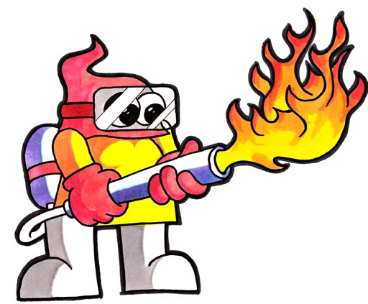

b) How many molecules of CO₂ will be produced?

