Type out on separate sheet following all instructions below. Individual Reports.

Prelab Background Information:

Define: London forces, dipole-dipole and hydrogen bonding.

Purpose: Restate the purpose (from lab sheet)

Hypothesis: Complete these two statements.

(a) As the number of electrons within a molecule increase the boiling point will _____________________. I think this because…..

Analysis:
Recreate Table 1 and add a column “Total number of electrons in molecule”. Calculate the total number of electrons for each molecule listed in Table 1:Boiling points of the Hydrogen Compounds of Elements in Groups 14-17
Eg.
Group | Hydrogen compound | Total number of electrons in molecule | Boiling point (oC)
14 | CH₄ | 10 | -162
 | SiH₄ | 18 | -112

(b) Create a scatter graph on excel. Number of electrons go on x-axis. Each group will be graphed separately on the same graph.
In excel input data

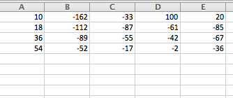
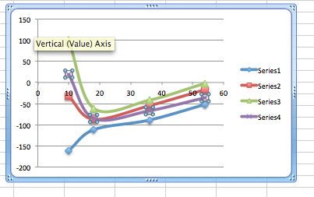
Choose XY scatter where lines are joined.
You will then have to right click on graph and ‘Select Data….’ option.
Choose “SWITCH ROW/COLUMN” option.
Title axis and Each Series as Group appropriate group number
Write molecular formula below each dot on graph

(c) Answer the Question

Evaluation: Complete (d) and (e) from lab sheet

