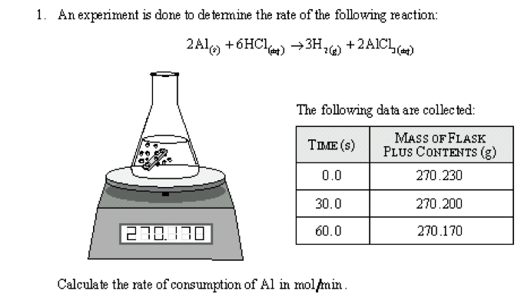

2. i) Write and balance an equation for the complete combustion for 1 mole of ethyne. Hf ethyne = +227 kJ/mol

ii) Determine the enthalpy (H) from standard heats of formation for the burning of 1 mole of ethyne. Assume all other reactants and products are in gas form.

3. Using Hess’s Law calculate H for the reaction
4 NH₃ (g) + 5 O₂ (g) → 4 NO (g) + 6 H₂O (g) given the equations below.

N₂ (g) + O₂ (g) → 2 NO (g) H = -180.5 kJ
N₂ (g) + 3 H₂ (g) → 2 NH₃ (g) H = -91.8 kJ
2 H₂ (g) + O₂ (g) → 2 H₂O (g) H = -483.6 kJ

4. The first antiseptic to be used in surgical operating rooms was phenol C₆H₅OH, a weak acid and a potent bactericide. A 0.550mol/L solution of phenol in was water was found to have a pH of 5.07. Calculate the K_{a}.

5. The experimental observations found below are obtained for the reaction: 2A + B + 2C 3X.

  - Write a general rate law for the above reaction and solve the exponent values [3]
  - Calculate the value for the rate constant ‘k’ with proper units [2]
  - Calculate the rate of production of X when [A] = [B] = [C] = 0.4 mol/L [1]
  - When the concentration of [A] is doubled what happens to the rate of production of X? [1]

Trial | Initial [A] (mol/L) | Initial [B] (mol/L) | Initial [C] (mol/L) | Rate of production of X (mol/(L*s))
1 | 0.1 | 0.1 | 0.1 | 3.0x10⁻⁴
2 | 0.2 | 0.1 | 0.1 | 1.2x10⁻³
3 | 0.1 | 0.3 | 0.1 | 3.0x10⁻⁴
4 | 0.2 | 0.1 | 0.2 | 2.4 x10⁻³

[3] 6. Write the structural formulas to represent the following compounds:

a) 3-amino-5-bromo-2,2-diethylheptane
b) 3-ethyl-2-methylhexanoic acid
c) 1-chloro-3-methyl-1,4-pentadiene

[4] 7. Write the structural formula for the primary product formed in each of the following reactions. Don’t forget catalysts involved.{note: it is not necessary to write formulas for the reactants}

- propane and chlorine (assume reaction is with only one molecule of Cl₂)
- addition of 1-propene using hydrogen chloride
- hydration of 1-pentene
- esterification of propanol and butanoic acid

[2] 8. Draw the Energy Level Diagram for Strontium, placing electrons in the proper orbital with the correct spin.

[4] 9. i) Explain VSEPR theory
ii) Draw the resonance structure for the formate ion CHO₂ ⁻¹.
iii) what is the shape around the central atom

10.
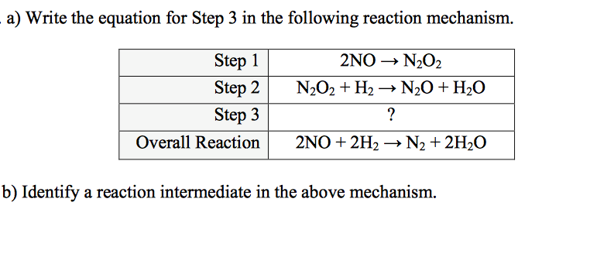

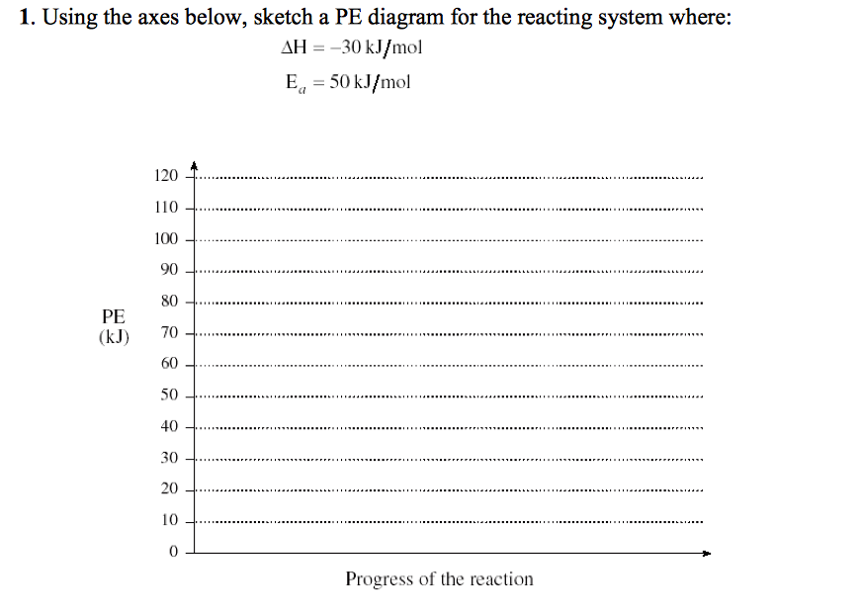
11.

