- An alarm clock draws 0.5 A of current when connected to a 120 volt circuit. Calculate its resistance.

- A subwoofer needs a household voltage of 110 V to push a current of 5.5 A through its coil. What is the resistance of the subwoofer?

- A circuit contains a 1.5 volt battery and a bulb with a resistance of 3 ohms. Calculate the current.

-----------------------------------------------------
- What current flows through the circuit shown below?
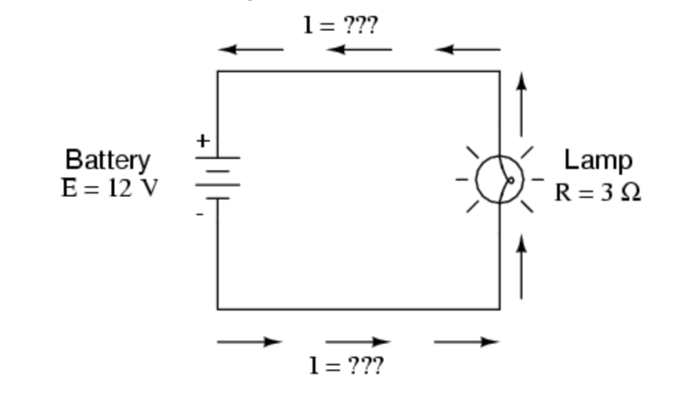

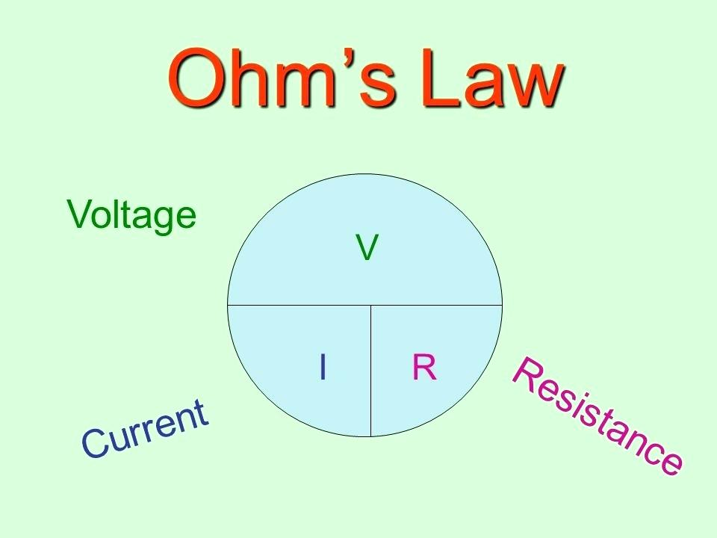

- If a toaster produces 12 ohms of resistance in a 120-volt circuit, what is the amount of current in the circuit?

- An electric heater works by passing a current of 100 A though a coiled metal wire, making it red hot. If the resistance of the wire is 1.1 ohms, what voltage must be applied to it?

-------------------------------------------------------

