Circuit Construction Kit
Name: _____________________________
Date: _____________________________
Open "Circuit Construction Kit (DC Only)" Simulation at http://phet.colorado.edu/en/simulation/circuit-construction-kit-dc. (The link opens a new window; click on "Run Now" to run the simulation.)

Answer the questions and record your meter readings on your own paper.

Part 1. Simple Circuit
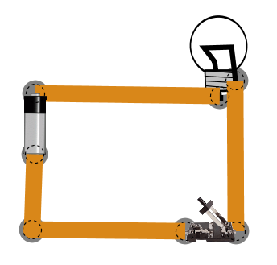
1. In Lifelike Visual Mode, Set up a simple circuit with one battery, one bulb, and one switch, as shown. See what happens when you open and close the switch.

2. Add a voltmeter by checking the “Voltmeter” box in the right-hand side control panel. Drag the black voltmeter wire so that the metal “point” is touching the negative (silver) end of the battery. Drag the red voltmeter wire so that the metal “point” is touching the positive (black) end of the battery. Record the voltmeter reading below.

3. Drag the voltmeter wires so you get a reading across the light bulb. Record the reading on the voltmeter.

 | with the switch open | 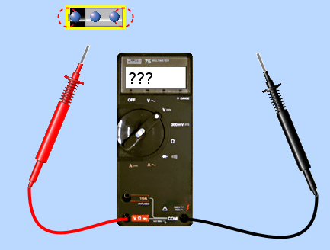  with the switch closed
Voltage across 1 battery
Voltage across Light bulb

- What do the blue dots represent in the circuit? ______________________

- How does the voltage reading across the battery compare to the light bulb voltage? (circuit one)

smaller voltage same voltage larger voltage

- Increase the voltage of the battery by right-clicking on the battery.

  - What happens to the brightness of the light when voltage increases?

The brightness of the bulb______________________________________.

  - What do your observations above indicate about the amount of energy being dropped off to the load (light bulb) by the electrons?

The amount of energy being dropped off by the electrons to the load (increase or decreases)

__________________ when the light bulb glows brighter.

Part 2. Series Circuit
    - Reset the battery Voltage back to 9V.
    - Set up a series circuit with 2 batteries, 1 bulb and one switch, as shown. (You can either add a battery to your previous circuit or click “Reset”)
Get this stamped by your teacher before you go any further.
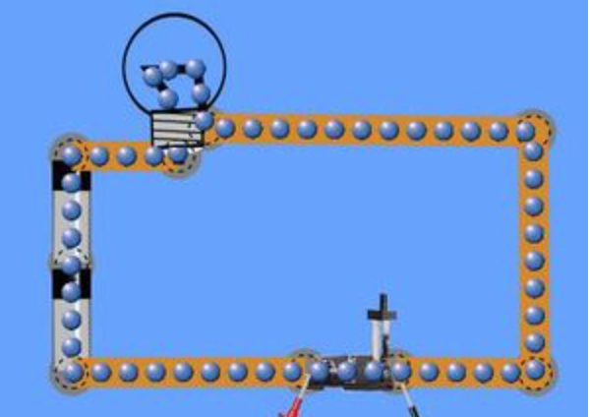
Draw this circuit using proper electric symbols.

Construction Complete

    - Close the switch so that the bulb lights up.
    - Add a voltmeter by checking the “Voltmeter” box in the right-hand side control panel.
    - Connected the voltmeter across the light bulb so that you get a positive reading.
    - Record your voltage and brightness of the bulbs in the chart below.
    - Repeat with a 3rd battery in series.
 | Voltage | Brightness of bulb
1 battery | 9V | dim
2 batteries in series
3 batteries in series

A. What do you notice about the brightness of the bulbs as more batteries are added in series? Circle one

Goes up Goes Down Stays the Same

B. Based on your observations above, does the amount of energy the electrons carry to the load increase, decrease or stay the same when cells are added in series?

Increase Decrease Stay the Same

C. What is the advantage to hooking up cells (batteries) in series?

Part 3. Parallel Circuit
- Confirm the battery voltage is 9V.
- Set up a parallel circuit with 2 batteries, 1 bulb and one switch.
Get this stamped by your teacher before you go any further.
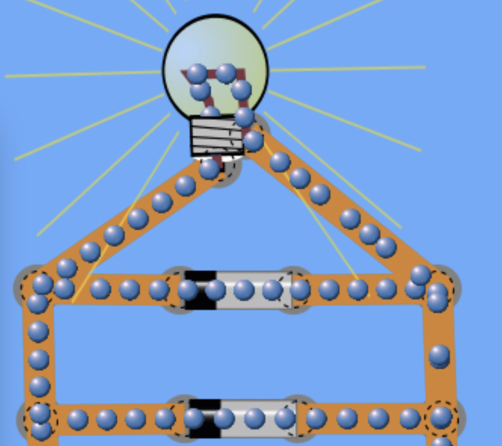
Draw this circuit using proper electric symbols.

Construction Complete

- Add a voltmeter by checking the “Voltmeter” box in the right-hand side control panel.
- Connect the voltmeter across the light bulb so that you get a positive reading.
- Record your voltage and brightness of the bulbs in the chart below.
- Repeat with a 3rd battery in parallel.
 | Voltage | Brightness of bulb
1 battery | 9V | dim
2 batteries in parallel
3 batteries in parallel

A. What do you notice about the brightness of the bulbs as more batteries are added in parallel ? Circle one

Goes up Goes Down Stays the Same

B. Based on your observations above, does the amount of energy the electrons carry to the load increase, decrease or stay the same when cells are added in parallel?

Increase Decrease Stay the Same

C. What is the advantage to hooking up cells (batteries) in parallel?

Part 4. Short Circuit
Connect two wires to a battery and join them all to form a simple circuit with no load or switch.
What has happened to your battery?

