Name:______________________
Lab: What Affects Resistance Ω ?
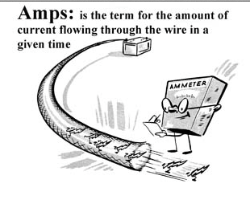
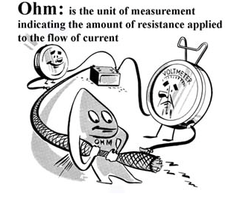

- Phet Simulation DC Circuit construction kit (DC only): http://bit.ly/1mOYoH6
- Click run now and allow Java to run
- Construct a simple series circuit containing one of each of the following: battery, light bulb, switch, contact ammeter
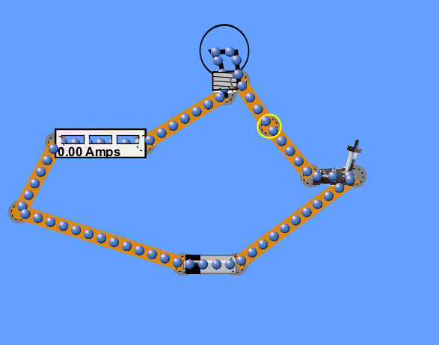
- Close the switch and record what the current in the circuit is in Amps ____________________

- Click on the voltmeter tool. Place the red wire to the left of the battery and the black wire on the right. Record the voltage in the circuit in Volts __________________________________

- Calculate the resistance in ohms of this circuit.
V =
I =
R = ?

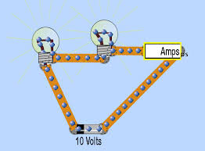
- Now, add another light bulb to the circuit in series.

- Record what the current in the circuit is in Amps
____________________. What happens to the current in the wire?
Increase Decrease Stays the Same
- Record the voltage in the circuit in Volts __________________________________What happened to the voltage in the circuit?
Increase Decrease Stays the Same
- Again calculate the resistance in ohms of this circuit using these new values

V =
I =
R = ?

- How did this new resistance compare to the 1st resistance calculated?
Increase Decrease Stays the Same
- So because another light bulb was added in series_____________________ decreased which caused _______________________ to increase. This means that it is harder for electrons to flow through the circuit.

- What happened to the brightness of the original light bulb when the 2nd one was added?

- Disconnect a wire and add a resistor in series with the two light bulbs and ammeter and switch.

- Record what the current in the circuit is in Amps ____________________. What happens to the current in the wire?
Increase Decrease Stays the Same

- Record the voltage in the circuit in Volts __________________________________What happened to the voltage in the circuit?
Increase Decrease Stays the Same
- Calculate the resistance of this new circuit using the values from above.
V =
I =
R = ?

- What does this effect of adding a resistor have on the speed/ability of electrons to flow through the circuit?
____________________________________________________________________________

