With electrical costs rising, most people consider the efficiency of an appliance to be of utmost importance when making a new purchase.
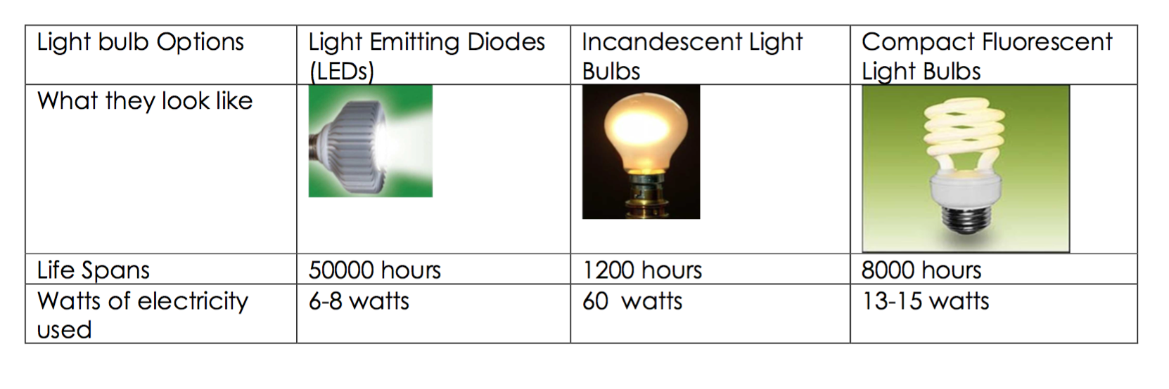
Even some simple choices, like changing a light bulb, can save money. Examine the chart below to compare the different power required for each bulb.
The efficiency of an electrical device is an important item to consider. Incandescent light bulbs use only about 5% of their input energy to create useable light energy and the remaining 95% is lost as thermal (heat) energy. Compact Fluorescent bulbs transform about 20% of their input energy into light energy and 80% is lost as thermal energy. They are more efficient then incandescent lights.
The more input energy that a device converts into usable output energy, the more efficient the device is.
Efficiency is calculated as a percentage:

Percent Efficiency = __________ x %

Electrical Energy, thermal energy, sound energy, mechanical energy, light energy – all types of energy can be measured and expressed in a unit called a
__________________.
Class Sample Calculations:
Example #1: Suppose a light bulb uses 480 J of input energy to produce 31 J of light energy. What is its percent efficiency?

Example #2: A certain light bulb consumes 200J of electrical energy per second, but only emits 25J of light energy per second. Calculate the efficiency of this bulb.

Example #3: A certain large wind turbine is able to transform 1,500,000J of mechanical energy into 1,000,000J of electrical energy every second.
- Calculate the efficiency of this turbine.

- How much thermal energy does this turbine 'waste' each second?

Electrical Devices: Practice Calculations

Efficiency (%) = Useful Energy Out x 100
Total Electric Energy In

Questions
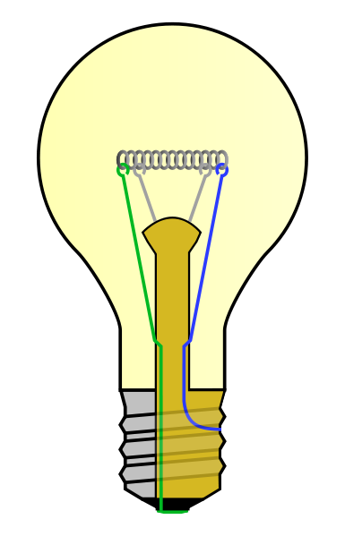
- A light bulb takes in 30J of electric energy per second. It transfers 3J as useful light energy and 27J as heat energy. Calculate the efficiency.

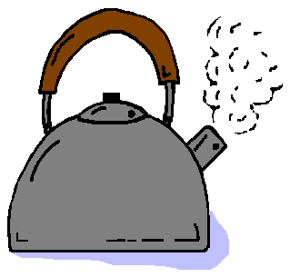
- A kettle takes in 2000J of electric energy per second. It transfers 1500J as useful heat energy and 500J is wasted as sound energy. Calculate the efficiency of the kettle.

- Calculate the efficiency of a hair dryer which takes in 3000J of electric energy per second and transfers 600J as useful heat energy. Calculate the % efficiency of the hair dryer.
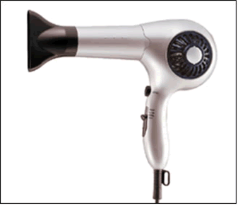

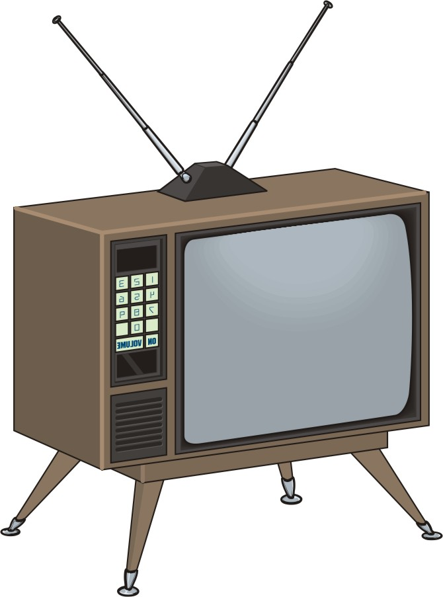
- Calculate the efficiency of a TV which takes in 5000J of energy per second and transfers 1000J as useful light energy and 1500J as useful sound energy. The remaining 2500J is wasted as heat energy. Calculate % efficiency of the TV.

