Name: ___________________________

Periodic Table Worksheet
The object of this lesson is to use the periodic properties of the elements to fill in the following chart (see Page 3). The code letters A through Z have been assigned to the first 26 representative elements in the periodic table (Elements 1-20 and 31-36). The code letters do not represent certain chemical symbols, that is, C may not be carbon, nor have the letters been assigned in alphabetical order.

These letters are presented in families, and your task is to arrange these letters in the proper location in the periodic chart. To do this, use the clues given pertaining to certain members of each family. The numbers in each square in the table are the atomic numbers of the elements.

The best way to start is to use the clues to find in which group each family belongs, and then to arrange the elements within the family using the other clues. The following elements belong together in families: WXYZ, STUV, ABC, DEF, GHI, JKL, MNO, and PQR.

The Clues
1. Element M is not the largest in its group and will react with element O to form both MO₃ and MO₂. It has 6 valence electrons.
2. Elements L & E are from the same period.
3. The radius of atoms of element P is smaller than the atoms of element R.
4. Element T has the lowest ionization potential in its family. It is very inert.
5. Element W is more reactive than element A, and element A is more reactive than element D. All three elements are in the same period.
6. The radius of atoms of element H are smaller than atoms of element I.
7. Element B is the least reactive alkaline earth element.
8. The Lewis dot notation for element K is . It is the 2nd biggest element in its family.
9. When elements K and L react, L tends to want to gain 3 electrons to complete its octet. It is the 4th smallest in its period.
10. Element Q has the highest electronegativity on the periodic table.
11. The atomic number of element V is one more than element P.
12. Element J is the most non-metallic and smallest element in its group.
13. Elements C & N are from the same period and react to form CN. C has the lowest ionization energy in its family. N is the largest in its family.
14. Element O is most stable with a charge of -2 . It is the smallest in its family.
15. Element Z is the most reactive metal on the periodic table.
16. The atomic number of Z is 16 more than the atomic number of Y.
17. Element E reacts with element P to form EP₃. Element E has the lowest electronegativity in its family. Element P has 7 valence electrons.
18. Element U is the smallest (size of the atoms) element in its period, but not in its group.
19. Element G has the highest ionization energy in its group.

The following Periodic Table shows only the Group A elements. Note that the atomic numbers jump from 20 to 31 in the fourth period. This is because elements 21 through 30, the transition elements, belong to the B Groups.
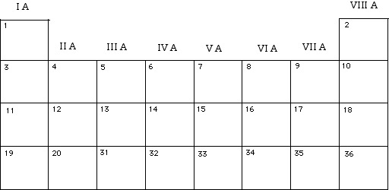

Match the letters (A-Z) with their corresponding elements.

A. J. S.

B. K. T.

C. L. U.

D. M. V.

E. N. W.

F. O. X.

G. P. Y.

H. Q. Z.

I. R.

