Practical Uses of Static Charges
We've all have experienced static electricity in one way or another. Those unexpected little shocks we get when we touch a doorknob or some other metalic object, the balloons that stick to the wall after being rubbed in the head, or hair itself standing straight when it comes close, all are produced by static electricity.
All those are common in our everyday lives, and at most they are fun to watch but, is there any practical uses of static electricity? or is it just a fun but useless electronic phenomenon?
The ability of opposite charges in static electricity is what's used when designing applications for it.
- Dust removal: There are some appliances that can eliminate dust from the air, like air purifiers. They use static electricity to alter the charges in the dust particles so that they stick to a plate or filter of the purifier that has an opposite charge as that of the dust (opposite charges attract each other). This effect is also used in industrial smokestacks to reduce the pollution that they generate, altough they work in a very large scale, the effect is basically the same as the home air purifier.

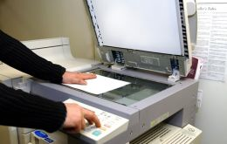
- Photocopy: Copy machines use static to make ink attract to the areas where we need the information copied. It uses the charges to apply the ink only in the areas where the paper to be copied is darker (usually this means text or other information) and not where the paper is white, this process is called xerography.

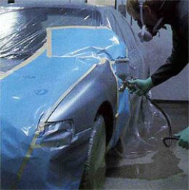
- Car painting: To make sure a car's paint is uniform and that it will resist the high speeds and weather to protect the car's metal interior, it is applied with a static charge. The metal body of the car is submerged in a substance that charges it positively, and the paint is charged negatively with the paint sprayer. This process ensures a uniform layer of paint, since when there is enough negative paint in the car the extra will be repelled by the paint already in the car. It also ensures that the paint won't fall off, since the electrical attraction between the paint and the car is stronger than if it was just sprayed.

Power from Static Electricity?
Many people have wondered if static electricity can be used as a source of power for homes and industries. Despite the extremely high voltages that can be generated with static electricity (tens of thousands of volts, compared to the 110V of a common power outlet) the amount current it can generate is very low, from microAmperes to a few miliAmperes (Ampere is the unit of electric current) and only for very short times.
Lightning can produce a considerable amount of energy, but the high voltages, current, temperature and speed of the discharge make it extremely difficult and inefficient to use or store.
Storing electricity is so inefficient for power plants because of the cost and also the amount of energy that can be stored is not significant enough to offset the expenses.

