Quantum Numbers
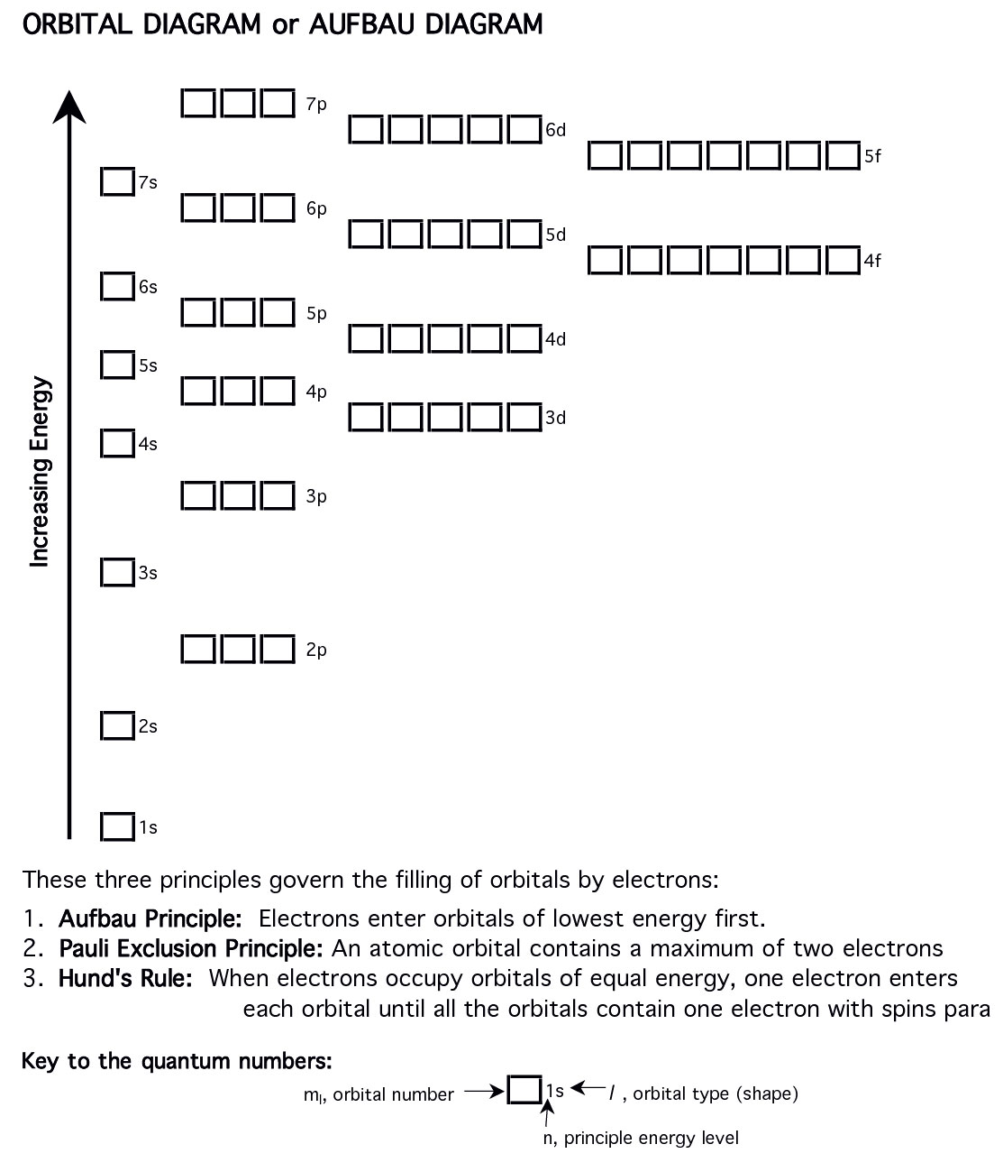Understanding the Quantum Numbers: This video tutorial will take you through
each of the quantum numbers and includes visuals and examples
http://youtu.be/KrXE_SzRoqw

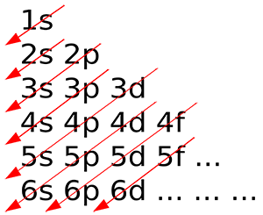

Writing Electron Configurations:
Let’s consider the GROUND STATE electron configuration for Neon (Ne) and Magnesium (Mg). The ground state means that all of the electrons are in there non-excited states and occupy the lowest energy levels.
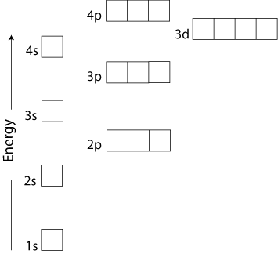
Draw the Aufbau Diagram for Neon; knowing it has ____________ electrons (look at periodic table).
Write the quantum numbers for the indicated electron in the diagram (Teacher will indicate the one).
$n =$ ____, $l =$______, $m_{l}=$ ______, $m_{s}=$ _______

Draw the Lewis structure for this atom (valence electrons)

We can also write what is known as the electron configuration for this atom as follows…

Neon (Ne):

Draw the Aufbau Diagram for Magnesium; knowing it has ____________ electrons.
Write the quantum numbers for the indicated electron in the diagram (Teacher will indicate the one).
$n =$ ____, $l =$______, $m_{l}=$ ______, $m_{s}=$ _______
Draw the Lewis structure for this atom (valence electrons)

We can also write what is known as the electron configuration for this atom as follows…

Magnesium (Mg):
Or shorthand:

Draw the Aufbau Diagram for Chlorine; knowing it has ____________ electrons.
Write the quantum numbers for the indicated electron in the diagram (Teacher will indicate the one).
$n =$ ____, $l =$______, $m_{l}=$ ______, $m_{s}=$ _______
Draw the Lewis structure for this atom (valence electrons)

We can also write what is known as the electron configuration for this atom as follows…

Chlorine (Cl):

Or shorthand:

Electron Configurations
Draw the electron configurations for the following atoms and ions (you an use the shorthand for high atomic numbers).
Ground State Atoms:
- Radium (Ra):
- Cobalt (Co):
- Bromine (Br):
- Silver (Ag):
Ions (Charged Atoms): (positive have _________electrons / negative have __________ electrons)
- Fe²⁺:
- O²⁻:
- K⁺:
- Co³⁺

