Quantum Quiz
/ 14
Name: _______________________________

- Write the appropriate scientist below their model of the atom. [5]

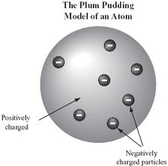
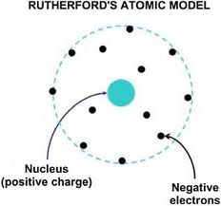

Aristotle
Laviosier
Thomson
Bohr
Rutherford
Democritus
Dalton
Quantum Theory

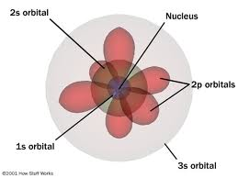
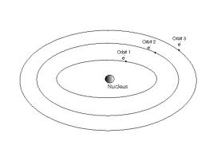

- List four possible quantum numbers for the 1st electron found in a 2p orbital. [2]

n =_________ l =_________ ml =_____________ ms =____________

- Write the electron configuration for Gallium (31 electrons). [2]

- Write the shorthand electron configuration for Gallium. [1]

- What would the Lewis Dot Diagram be for Gallium? [1]

- Draw Energy level diagram (do on the back) for Gallium ion Ga ⁺³. [3]

