Lab Investigation: Comparing the Reactivity of Alkanes and Alkenes – Saturated and Unsaturated Fats

Introduction: (Complete the following blanks as your introduction)

Hydrocarbons are classified as Aromatic and Aliphatic. Aliphatic hydrocarbons that have single bonds are called ___________________. They have the general formula ________________. Double bonded hydrocarbons are called _____________________ and have the general formula ___________________. Triple bonded hydrocarbons are called ___________________ and have the general formula ___________________.

Organic molecules that have double or triple bonds are called (delete the one that does not apply) saturated or unsaturated hydrocarbons. They are (delete the one that does not apply) more or less reactive than single bonded hydrocarbons. These type of fats are (delete the one that does not apply) more or less healthy for you.

In this lab aqueous potassium permanganate will be used to test for degree of unsaturation. KMnO₄ will only react if there are unsaturated fats (alkenes/alkynes) present in the sample. This is shown by a colour change from purple to _________________. When KMnO₄ comes in contact with oils that have primarily saturated fats (alkanes) the colour remains _________________.

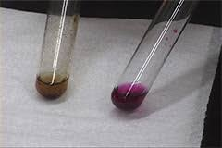

Figure 1: KMnO4 test for unsaturation.
Below is a list of the type of saturated and unsaturated fats that are found in different fats and oils.

Table 1:
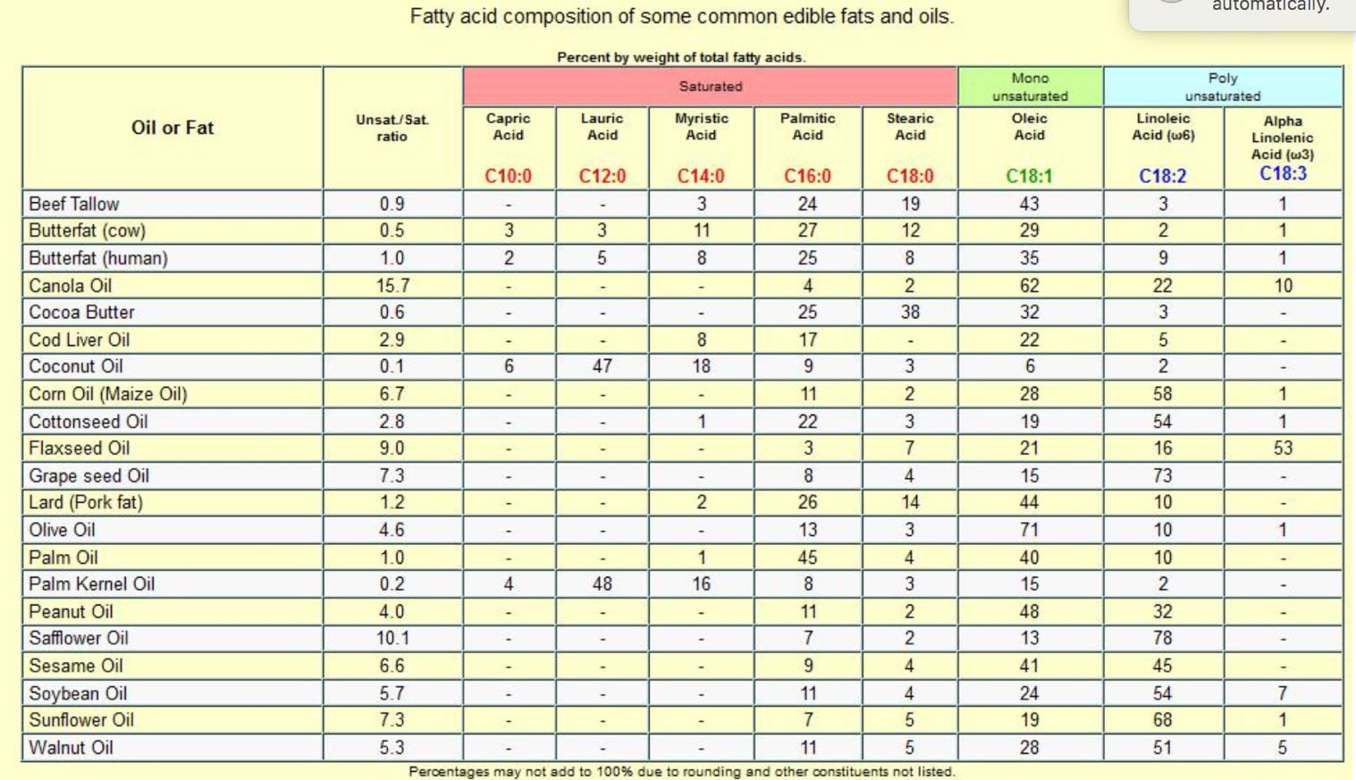

Below is an example of palmitic acid, a saturated fat found in every oil listed above. Copy and paste an image of 1 more saturated fats and 1 unsaturated fat found in oils you tested.

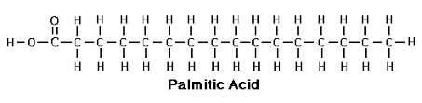

Purpose: Copy from the lab sheet.

The oils/fats that will be tested in this lab include:

Safety: Include safety precautions listed on lab sheet

Procedure: Refer to lab sheet. Reference: Chemistry 11 Chapter: Chemistry of Hydrocarbons, McGraw Hill Ryerson. Toronto. Pg 555

Observation Table: Create a table to display your results

Conclusion: APE format – Restate the Purpose, State your findings, Explain.

