SCH4U1
IONIC SOLIDS

Ionic solids result from the reaction of a metal and a non-metal. Because of the large electronegativity difference, electron(s) transfer from the metallic atom to the non-metallic atom and the resultant ions then attract each other. Thus, as one would expect, ionic solids are held together by ionic bonds. Any ionic crystal can be considered to be an array of positive and negative ions, arranged in such a way that every positive ion has only negative neighbours and vice versa. There are no distinct molecules in an ionic solid. The attraction that the oppositely charged ions have for one another gives the ionic solid its stability.
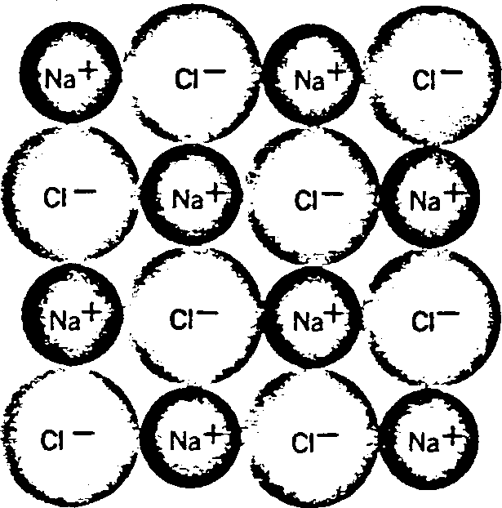

Ionic solids are hard and have high melting points due to the strong ionic bonds holding the ions together. Ionic solids are brittle and do not conduct electricity because there are no mobile electrons in them. Every electron in an ionic solid belongs to an ion and is unable to move to any other ion. Molten ionic solids are able to conduct electricity, however, although not as well as metals. The electric charge is carried through a molten ionic compound by slow-moving positive and negative ions rather than fast-moving electrons. When ionic solids dissolve in water, they dissociate into ions and thus form solutions which conduct electricity. When comparing the properties of ionic solids, one needs to consider the strength of the ionic bonds in the solids. The strength of an ionic bond depends on two factors. First of all, since the charge of an ion acts as though it were concentrated at the center of the ion, one can see that the larger the radii of the ions, the greater is the distance between the ions and the smaller is the force of attraction. Thus, for example, NaCl has a higher melting point than CsCl because its ions are smaller and therefore can attract each other more strongly. Second of all, the force of attraction between charged ions is directly proportional to the magnitude of the charges on the ions. Thus, for example, MgO has a higher melting point than NaCl because it consists of ions with greater charges on them.
Melting Point (ºC) |  | Solubility  (g/100g H2O @ 0ºC) |  | Melting Point (ºC) |  | Solubility  (g/100g H2O @ 0ºC)
CsCl | 646 | 161 |  | MgO | 2800 | 0.0006
NaCl | 800 | 35.7 |  | NaCl | 800 | 35.7

SCH4U1

METALLIC SOLIDS

As a group, metals have small numbers of valence electrons. Therefore, metals have outer energy levels which are less than half filled. Also, metals are readily ionized so their valence electrons are not tightly held. In addition, metals are very good conductors of electricity. All of these factors tend to indicate that the valence electrons in metals are delocalized (able to move) throughout the solid. Thus, one can think of a metallic solid as being an array of positive ions in a "sea" of mobile electrons. The positive nuclei are not attracted to one another; they are all attracted to the cloud of electrons. This cloud of electrons serves as the "glue" which holds the nuclei together. Therefore, a metallic bond is the attraction between a cloud of mobile electrons and the positive metallic ions arranged in that cloud.

This model can be used to explain the properties of metals:
- It is the mobility of the electrons that allows metals to conduct electricity.
- Metals are also good heat conductors because of the mobile electrons. When one end of a metallic solid is warmed, the electrons in that region acquire large amounts of kinetic energy. These electrons move rapidly through the solid and give extra energy to the atoms in the cooler part of the solid.
- Metals can be drawn into wires (ductile) and can be hammered into sheets without cracking (malleable). This is because one plane of ions in a metallic crystal can slip over another and, as it does so, the electron cloud merely distorts to maintain bonding.
- The mobile electrons are also able to absorb and re-emit light of all wavelengths. Therefore, metals are good reflectors of light,.which explains why they have a lustre. Finally, as one goes across a period of the periodic table, one finds that metals become harder and they become more difficult to melt or boil, too. This is because, as one goes across a period, there is an increasing number of valence electrons. Thus, there are more electrons for the positive nuclei to be attracted to and therefore the metallic bonding is stronger.

The Electron Sea Model of a Metallic Crystal
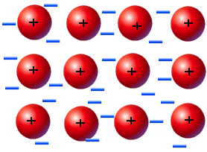

Positive Metal Ion

Delocalized Electron “Cloud”

Geometry of Metals

Almost all pure metals crystallize in one of the following three patterns.

1) Body-Centred Cubic Structure | 2) Hexagonal Close-Packed Structure | 3) Cubic Close-Packed Face-Centred Cubic Structure
8 neighbours/atom | 12 neighbours/atom | 12 neighbours/atom
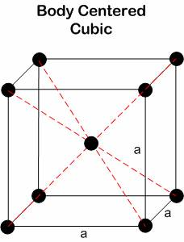 | 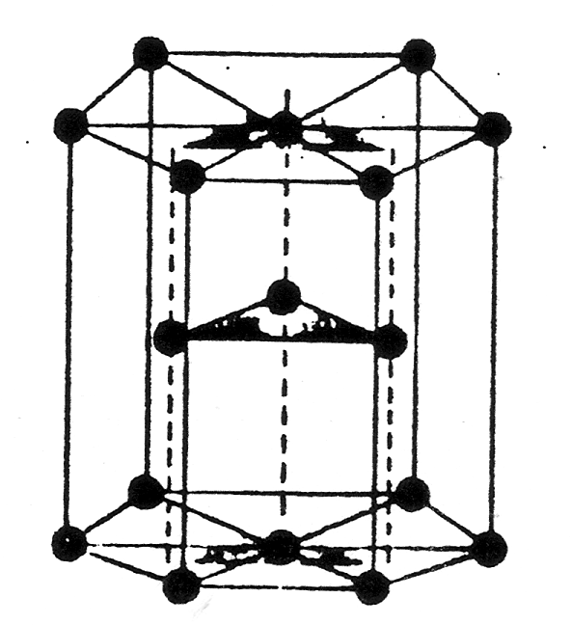 | 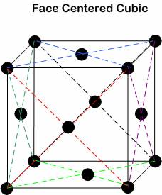
e.g. Li, Na, K, Fe | e.g. Be, Mg | e.g. Al

Metallic Solids – Questions

1. Lithium is far more malleable than aluminum. Explain why this is true.

2. Which element would have the highest heat of vapourization, K or Sc? Explain.

SCH4U1
Covalent Network Solids

Network solids consist of atoms covalently and polar-covalently bonded to each other in a continuous pattern, forming a crystal. Network solids do not contain molecules since bonding is continuous. The number of covalent bonds makes them very hard and brittle. Network solids do not conduct since the valence electrons are involved in bonding.

Properties of Network Solids: - high melting point, boiling point
- hard and brittle
- non-conductive
- not soluble in water

Examples:

