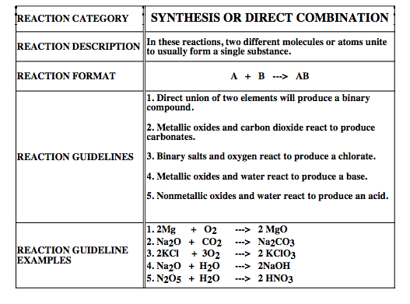
Complete the following word equations. Write the balanced chemical equation below.

Ex. 1. calcium + oxygen Calcium oxide

2Ca + O₂ 2CaO

2. copper + sulfur copper(II) sulfide

3. calcium oxide + water calcium hydroxide

4. hydrogen + chlorine

5. silver + sulfur

6. chromium + oxygen

7. aluminum + bromine

8. sodium + iodine

9. aluminum + oxygen

* Read the information on the front for these tricky ones! All you need to do is predict the product and balance these ones. No word equations required.

10. MgCl₂ + O₂ --->

11. P₂O₃ + H₂O --->

12. K₂O + H₂O --->

13. BaO + CO₂ --->

14. BeO + CO₂ --->

15. Al₂O₃ + H₂O --->

16. SO₃ + H₂O --->

17. NaCl + O₂ --->

